**--Full adder using half adder**

**1. Code**

----------------------------------------------------------------------------------

library IEEE;

use IEEE.STD_LOGIC_1164.ALL;

use IEEE.STD_LOGIC_ARITH.ALL;

use IEEE.STD_LOGIC_UNSIGNED.ALL;

entity FULL_ADDER_STR is

Port ( a,b,c : in STD_LOGIC;

sum,carry : out STD_LOGIC);

end FULL_ADDER_STR;

architecture Structural of FULL_ADDER_STR is

component halfadd

port (a,b: in STD_LOGIC ;

sum,carry : OUT STD_LOGIC );

end component ;

SIGNAL sum1,carry1, sum2, carry2 : STD_LOGIC ;

begin

halfadder1: halfadd port map (a => a, b => b, sum => sum1 ,carry => carry1 );

halfadder2: halfadd port map (a => sum1, b => c, sum =>sum ,carry =>carry2 );

carry <= carry1 or carry2 ;

end structural;

**Code 2: for Half Adder**

library IEEE;

use IEEE.STD_LOGIC_1164.ALL;

use IEEE.STD_LOGIC_ARITH.ALL;

use IEEE.STD_LOGIC_UNSIGNED.ALL;

entity halfadd is

Port ( a,b, : in STD_LOGIC;

sum,carry : out STD_LOGIC);

end halfadd;

architecture dataflow of halfadd is

begin

sum <= a xor b;

carry <= a and b;

end dataflow;

**2. RTL Schematic**

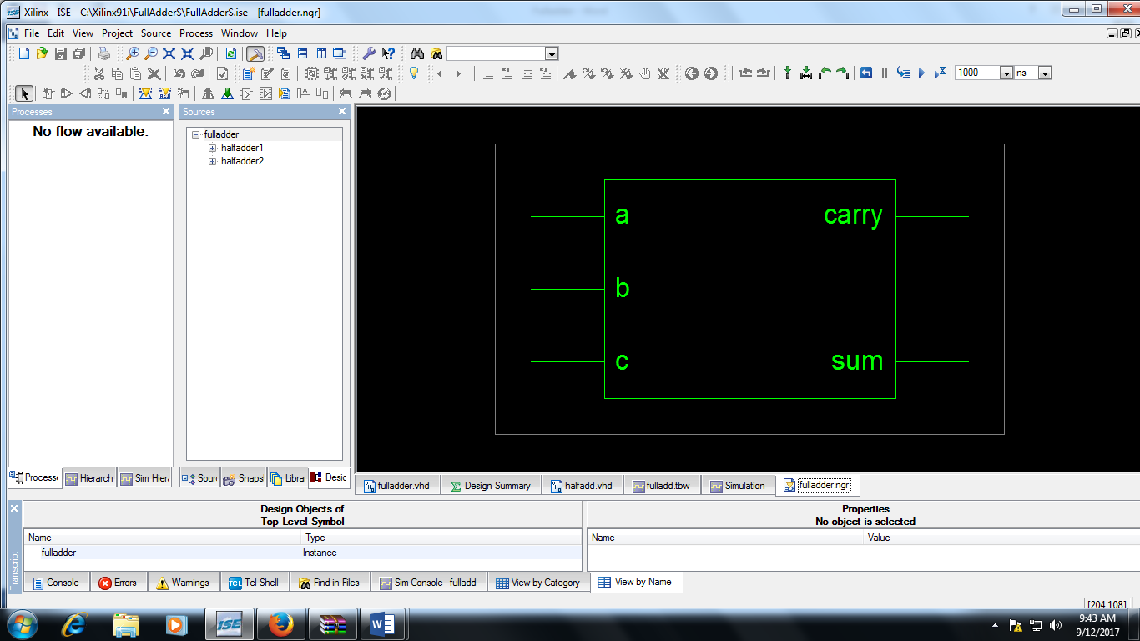

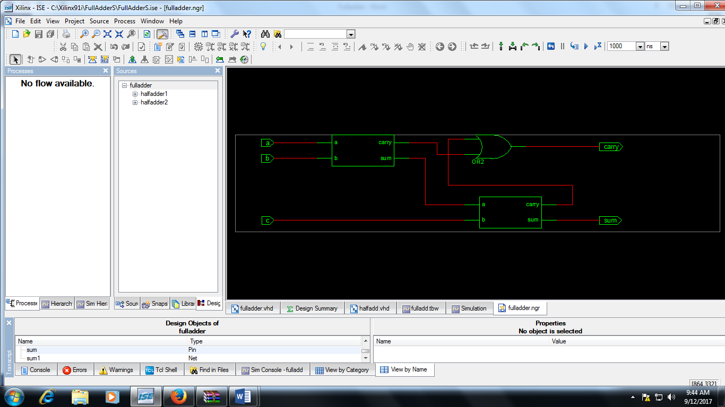

**3. Simulation Output**

